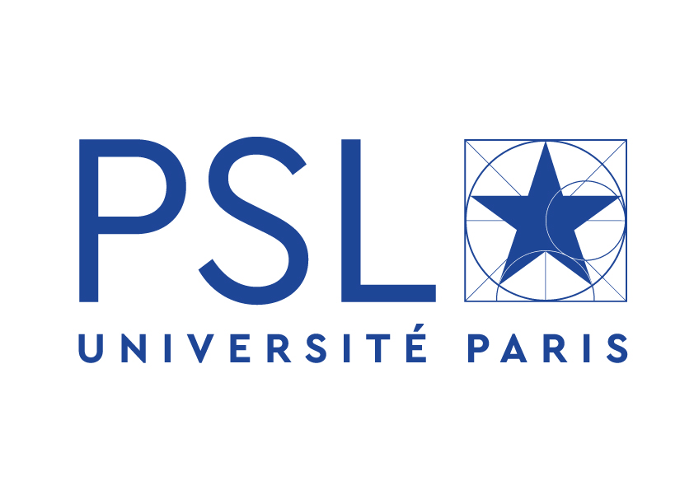
Institut Curie - 26 rue d’Ulm - 75248 PARIS Cedex 05 - FRANCE

POST-DOCTORAL POSITION IN IMMUNOLOGY AT THE INSTITUT CURIE IN THE CENTER OF PARIS

Starting February 2019

Applicants are invited for a 3-years position within a research group led by Dr. Olivier Lantz to work on Mucosal Associated Invariant T (MAIT) cells biology. The project can address any issue regarding this topic and will be determined with the applicant according to his/her expertise and wishes.

The team studying MAIT cell biology encompasses 11 persons: 2 staff-scientists, 2 post-docs, 4 PhD students, and 2 technicians. The techniques used are multicolor FACS analysis and sorting, quantitative PCR, transgenic and KO mice, transfectants, NGS, cellular immunology… etc. Many studies have to be done in vivo.

The group is part of a 130-person immunology department headed by S. Amigorena. The lab is located within the Institut Curie campus in the center of Paris. The building is equipped with state-of-the-art facilities (imaging, proteomic, animal facility, genomic and cytometry). The Institute hosts around 1100 bench scientists including many foreign post-doctoral fellows.

Candidates will have a PhD. in immunology. He/she should have a demonstrated successful experience in immunology or related topics testified by publications in the field. Strong motivation and autonomy and ability to quickly and effectively develop new projects in relation with the group leader and collaborators will be essential.
Written and spoken English is mandatory.

Informal inquiries can be made to Dr. Olivier Lantz. See https://science.institut-curie.org/research/integrated-biology/u932-immunity-and-cancer/team-lantz/

Please send CV, motivation letter and contact details of at least two persons able to provide references to sylvia.trival@curie.fr

References
- F Legoux*, J. Gilet*, E. Procopio, K. Echasserieau, K. Bernardeau and O. Lantz. 2019. Molecular mechanisms of lineage decisions in metabolite-specific T cells. Nature Immunol. 20, 1244-1255.
- F. Legoux, D. Bellet, C. Daviaud, Y.El Morr, A. Darbois, K. Niort, E. Procopio, M. Salou, J. Gilet, B. Ryffel, A. Balvay, A. Foussier, M. Sarkis, A. El Marjou, F. Schmidt, S. Rabot and O. Lantz. 2019. Microbial metabolites control the thymic development of Mucosal Associated Invariant T cells. Science 366, 494-499.
- Salou, M.*, F. Legoux*, J. Gilet*, A. Darbois, A. du Halgouet, R. Alonso, W. Richer, A.G. Goubet, C. Daviaud, M. Menger, E. Procopio, V. Premel, and O. Lantz. 2019. A common transcriptomic program acquired in the thymus defines tissue residency of MAIT and NKT subsets. J Exp Med Jan 7;216(1):133-151.
- Y. Cui*, K. Franciszkiewicz*, Y. Mburu, S. Mondot, V. Premel, E.Martin, A. Kachaner,L. Duban, M Ingersoll, S.Rabot, J. Jaubert, J.-P. De Villartay, C. Soudais, O. Lantz. 2015. Mucosal-associated invariant T cell-rich congenic mouse strain allows functional evaluation. JCI 125(11):4171-85.
- L Le Bourhis, E Martin, I Péguillet, A Guihot, N Froux, M Coré, E Levy, M Dusseaux, V Meyssonnier, V Premel, C Ngo, B Riteau, L Duban, D Robert, M Rottman, C Soudais, O Lantz. 2010. Anti-bacterial reactivity of Mucosal Associated Invariant T cells. Nature Immunology 11(8): 701.

